ONLINE APPENDIX

The Effect of Racial and Ethnic Attitudes on Asian Identity in the U.S

Hussain Hadah*

*. [Hussain Hadah](https://orcid.org/0000-0002-8705-6386): Department of Economics, Tulane University, 6823 St. Charles Ave., New Orleans, LA 70118, United States (e-mail: [hhadah@tulane.edu](mailto:hhadah@tulane.edu), phone: +1-602-393-8077)

# Data

Figure A.1: Examples of an Implicit Association Test

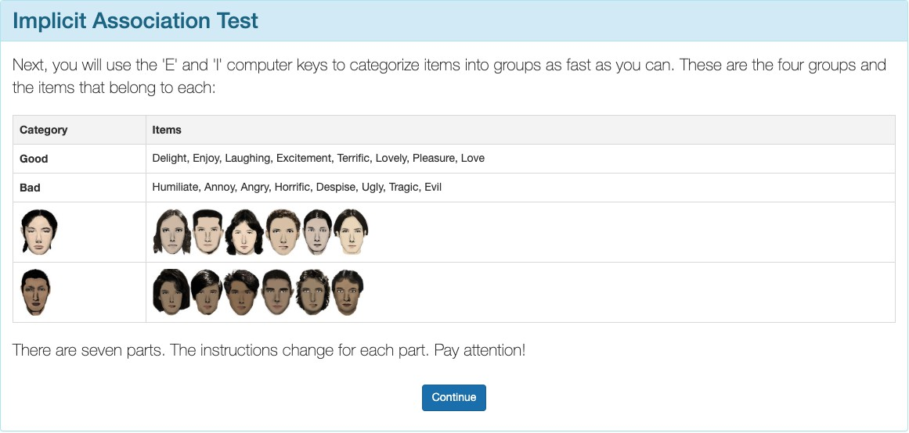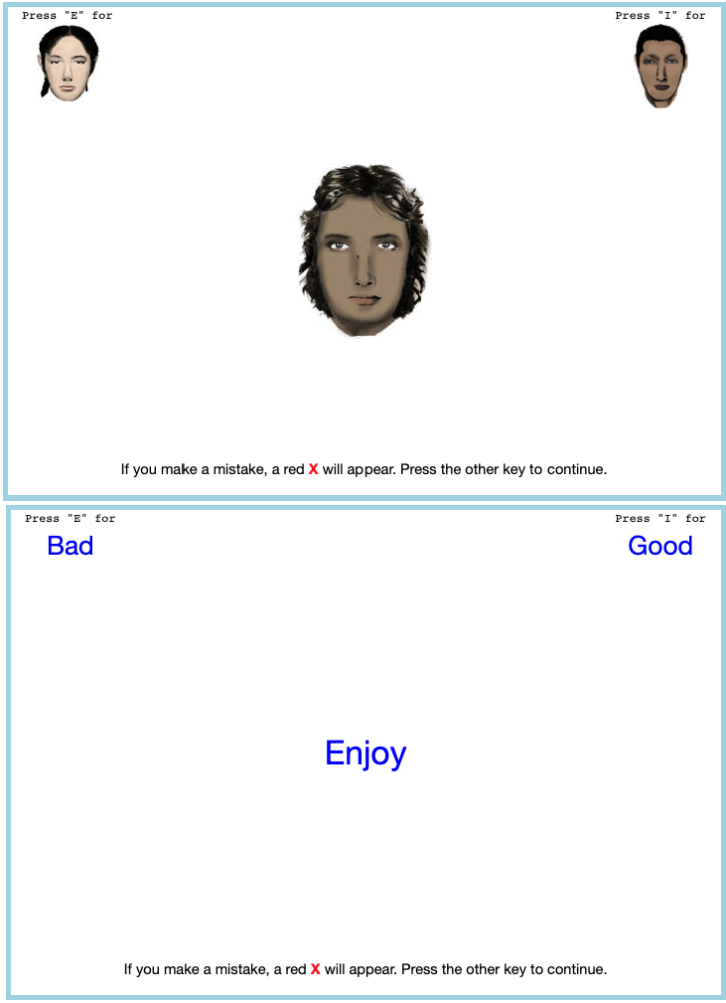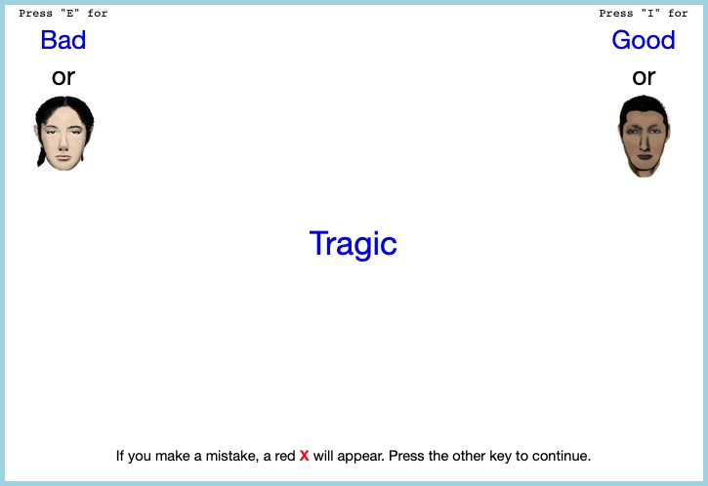

Here are a few examples of what a respondent would see on an implicit association test.

# Tables

Table A.1: Subjective Asian Identity and Asian Bias

|  |  |  |  |  |  |  |  |  |
| --- | --- | --- | --- | --- | --- | --- | --- | --- |
|  | (1) | (2) | (3) | (4) | (5) | (6) | (7) | (8) |
| Ai | Ai | Ai | Ai | Ai | Ai | Ai | Ai |
| Bias | −0.04*** | −0.14*** | −0.02*** | −0.02 | −0.03*** | −0.07** | −0.10*** | −0.04 |
|  | (0.01) | (0.04) | (0.01) | (0.03) | (0.01) | (0.03) | (0.03) | (0.03) |
| Female | −0.01** | −0.01** | −0.01** | −0.01* | −0.01** | −0.01* | −0.01* | −0.01* |
|  | (0.00) | (0.00) | (0.00) | (0.00) | (0.00) | (0.00) | (0.00) | (0.00) |
| College Graduate: Mother | 0.01 | 0.01 | 0.01 | 0.01 | 0.01 | 0.01 | 0.01 | 0.01 |
|  | (0.01) | (0.01) | (0.01) | (0.01) | (0.01) | (0.01) | (0.01) | (0.01) |
| College Graduate: Father | 0.01** | 0.01* | 0.01** | 0.01** | 0.01** | 0.01** | 0.01** | 0.01** |
|  | (0.01) | (0.01) | (0.01) | (0.01) | (0.01) | (0.01) | (0.01) | (0.01) |
| Both parents Asian | 0.63*** | 0.63*** | 0.62*** | 0.62*** | 0.63*** | 0.63*** | 0.63*** | 0.62*** |
|  | (0.03) | (0.03) | (0.03) | (0.03) | (0.03) | (0.03) | (0.03) | (0.03) |
| First Gen | 0.01 | 0.02 | 0.02* | 0.02** | 0.02* | 0.02** | 0.02* | 0.02** |
|  | (0.01) | (0.01) | (0.01) | (0.01) | (0.01) | (0.01) | (0.01) | (0.01) |
| Second Gen | 0.02 | 0.02 | 0.01 | 0.02 | 0.02 | 0.02 | 0.02 | 0.02 |
|  | (0.01) | (0.01) | (0.01) | (0.02) | (0.02) | (0.02) | (0.02) | (0.02) |
| N | 129078 | 129078 | 129078 | 129078 | 129078 | 129078 | 129078 | 129078 |
| Region FE |  |  |  |  | X | X |  |  |
| Year FE |  | X |  | X |  | X |  |  |
| State FE |  |  | X | X |  |  |  | X |
| Year-Region FE |  |  |  |  |  |  | X | X |

* p < 0.1, ** p < 0.05, *** p < 0.01

1 I include controls for sex, quartic age, and parental education.

2 Standard errors are clustered on the state level.

Table A.2: Relationship Between Bias and Self-Reported Asian Identity: By Gen- eration

i i

|  |  |  |  |  |
| --- | --- | --- | --- | --- |
|  | (1) | (2) | (3) | (4) |
| Ai | A1 | A2 | A3  i |
| Bias | -0.09*** | -0.05 | -0.08** | -0.08** |
|  | (0.03) | (0.04) | (0.03) | (0.03) |
| Female | -0.01* | -0.01 | 0.00 | -0.01 |
|  | (0.00) | (0.01) | (0.00) | (0.01) |
| College Graduate: Mother | 0.01 | -0.01 | 0.01 | 0.03 |
|  | (0.01) | (0.01) | (0.01) | (0.02) |
| College Graduate: Father | 0.01** | 0.02** | 0.00 | -0.01 |
|  | (0.01) | (0.01) | (0.01) | (0.02) |
| Observations | 129,078 | 15,499 | 80,137 | 33,442 |
| Mean | 0.65 | 0.44 | 0.22 | 0.66 |
| Year *×* Region FE | X | X | X | X |

* p < 0.1, ** p < 0.05, *** p < 0.01

1 Each column is an estimation of a heterogeneous effect of regression (4) by generation with region × year fixed effects. I include controls for sex, quartic age, fraction of Asians in a state, and parental education. I also added parents’ (AA, AW, and WA) and grandparents’ (AAAA, AAAW, AAWA, etc.) type dummy variables to the regression on second and third generation immigrants, where A is objectively Asian (born in a Asian country) and W is objectively White (native-born). Standard errors are clustered on the state level.

2 The samples include children ages 17 and below who live in intact fami-

lies. First-generation Asian immigrant children that were born in a Asian country. Native-born second-generation Asian immigrant children with at least one parent born in a Asian country. Finally, native-born third- generation Asian immigrant children with native-born parents and at least one grandparent born in a Asian country.

3 Data source is the 2004-2021 Current Population Survey.

Table A.3: Relationship Between Bias and Self-Reported Asian identity Among Second-Generation Asian Immigrants: By Parental Type

|  |  |  |  |  |  |  |  |  |
| --- | --- | --- | --- | --- | --- | --- | --- | --- |
| Parents Type |  | All |  | Both Parents from Asian Country |  | Father  from Asian Country |  | Mother  from Asian Country |
|  |  |  |  | (AA) |  | (AW) |  | (WA) |
|  |  | (1)  A2 |  | (2)  A2 |  | (3)  A2 |  | (4)  A2 |
| Bias |  | -0.08** |  | -0.05 |  | -0.15 |  | -0.10 |
|  |  | (0.03) |  | (0.03) |  | (0.10) |  | (0.06) |
| Female |  | 0.00 |  | -0.01 |  | -0.03* |  | 0.01 |
|  |  | (0.00) |  | (0.00) |  | (0.02) |  | (0.02) |
| College Graduate: Mother |  | 0.01 |  | -0.01* |  | 0.10*** |  | 0.03 |
|  |  | (0.01) |  | (0.01) |  | (0.03) |  | (0.02) |
| College Graduate: Father |  | 0.00 |  | 0.01 |  | -0.05** |  | 0.01 |
|  |  | (0.01) |  | (0.01) |  | (0.02) |  | (0.03) |
| Observations |  | 80,137 |  | 50,835 |  | 9,055 |  | 20,247 |
| Year *×* Region FE |  | X |  | X |  | X |  | X |
| Mean |  | 0.73 |  | 0.97 |  | 0.39 |  | 0.3 |

* p < 0.1, ** p < 0.05, *** p < 0.01

1 Each column is an estimation of a heterogeneous effect of regression (4) by type of parents with region × year fixed effects. I include controls for sex, quartic age, fraction of Asians in a state, and parental education. Standard errors are clustered on the state level.

2 The samples include second-generation Asian children ages 17 and below who live in intact families. Native-born second-

generation Asian immigrant children with at least one parent born in a Asian country.

3 Column (1) includes the results to regression (4) on all second-generation immigrants, column (2) includes the results to regression (4) on second-generation immigrants that who has a father and mother that were born in a Asian country (AA), column (3) includes the results to regression (4) on second-generation immigrants that who has a father that was born in a Asian country and a native-born mother (AW), and column (4) includes the results to regression (4) on second-generation immigrants that who has a native-born father and a mother that was born in a Asian country (WA).

4 Data source is the 2004-2021 Current Population Survey.

Table A.4: Logistic Regression Analysis of Bias and Interracial Marriages

|  |  |  |  |  |
| --- | --- | --- | --- | --- |
|  | Asian Men |  | Asian Women |  |
| (1) | (2) |  | (3) |
| Interethnic | Interethnic |  | Interethnic |
| Bias 0.38*** | −0.19 |  | 0.33** |  |
| (0.11) | (0.16) |  | (0.14) |  |
| College Graduate: Wife 0.35*** | 0.44*** |  | 0.56*** |  |
| (0.04)  College Graduate: Husband −0.06 | (0.06)  −0.03 |  | (0.05)  −0.15*** |  |
| (0.04) | (0.06) |  | (0.05) |  |
| Observations 69, 800 | 52, 032 |  | 60, 171 |  |
| Year *×* Region FE X | X |  | X |  |
| * p < 0.1, ** p < 0.05, *** p < 0.01 |  |  |  |  |

1 This is the result to estimating (5) as a logistic regression. The coefficients are expo- nentiated, thus should be interpreted as odds ratios.

2 I include controls for partners’ sex, age, education, and years since immigrating to the

United States. Standard errors are clustered on the household level.

3 Data source is the 2004-2020 Current Population Survey Data.

# Figures

Figure A.2: Scatter Plot of Proportion Subjectively Asian on Bias

1. Year < 2015

1. Year ⩾ 2015

Here are two scatter plots showing the relationship between bias and subjective Asian population in a state. Each dot represents a state in a certain year. Percent subjectively Asian = #Asian

Population

*Source.* 2004-2021 Current Population Survey.

## Using Lubotsky and Wittenberg (2006) to Construct Bias In- dex

In Lubotsky and Wittenberg (2006), the authors propose a method to reduce measurement error in proxies by constructing a composite index. The Lubotsky- Wittenberg (henceforth LW) consider a model where a covariate is unobserved. Therefore, they use two proxies in its place, which will have measurement error. Thus, the LW method allows researchers to use two proxies that are error-ridden.

LW consider a setup with the following model:

y = α + βx*∗* + ϵ x1 = x*∗* + µ1

x2 = x*∗* + µ2

Where x*∗* is the unobserved covariate, x1i and x2i are the proxies, and the mea- surement errors µ1 and µ2 are assumed to be classical and allowed to covary. The covariance matrix of the errors is given by:

i

 σ2 σ 

12

Σ =  1 

σ12 σ2

2

Replacing the unobserved x*∗* with x1 or x2 yields the following expectations of the OLS estimates:

2

E β1 = β σ

ˆ x*∗*

σ2*∗* + σ2

2

; ˆ x*∗*

E β2 = β σ

σ2*∗* + σ2

x 1 x 2

Both estimates are biased; the one with the smaller variance of the measure- ment error being less biased.

LW then propose defining a new proxy x3 as a weighted average of x1 and x2:

x3 = λx1 + (1 − λ)x2

To minimize the attenuation bias in the OLS estimate of β, they solve for the optimal value of λ:

*∗* σ2 − σ12

λ = 2 2 2

σ1 + σ2 − 2σ12

This optimal value of λ is not directly useful because the variances of the mea- surement errors and their covariance are unobserved. However, if you estimate a bivariate regression using OLS (i.e., regress y on x1 and x2), then the expectation of the sum of the two coefficient estimates is identical to the expectation of the OLS coefficient estimate on x3 in a univariate regression using the optimal choice of λ:

E βˆ 1 + βˆ 2 = E βˆ x3

Thus, OLS produces an estimate of β with the least bias by optimally combin- ing the information in x1 and x2.

# References for Online Appendix

Lubotsky, Darren, and Martin Wittenberg. 2006. “Interpretation of Regressions with Multiple Proxies.” *The Review of Economics and Statistics* 88, no. 3 (Au- gust 1, 2006): 549–562. <https://doi.org/10.1162/rest.88.3.549>